
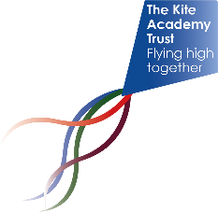
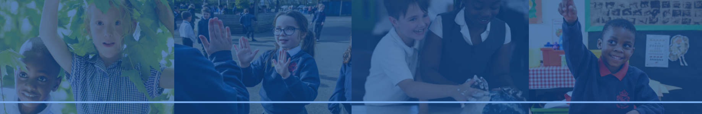

The Kite Academy Trust

POSITIVITY ▪ INTEGRITY ▪ RESILIENCE ▪ RESPECT ▪ ASPIRATION

Remote Education
Information for Parents and Carers
A guide to how we support learning when pupils cannot attend school
Aligned to DfE guidance (August 2024)

Our Principles
School attendance remains the priority for every child. Remote education is used only when attendance is not possible and is intended to help pupils remain connected to learning, teachers and peers. We aim to ensure learning continues with high expectations, consistency and inclusion.

When Remote Education May Be Used
This may include emergency school closures, severe disruption, recovery from operations or injuries, and other exceptional circumstances where a pupil is unable to attend but is well enough to learn. Remote provision will be temporary and reviewed regularly.

What Families Can Expect
- A broad and ambitious curriculum
- Consistent use of digital platforms
- Clear communication
- Regular opportunities for learning
- Constructive feedback
- Support when difficulties arise
- Support for all pupils including those with additional needs

What Learning May Look Like
Remote learning may include live lessons, recorded teaching, Oak National Academy resources, guided practice, reading activities, independent tasks and teacher feedback. Provision will be adapted according to age and stage.

Digital Access and Equipment
We recognise that access to devices and connectivity can be challenging. Schools will work with families to identify barriers and, where possible, provide support, loan devices or alternative arrangements including printed materials.

Supporting Children with SEND
Teachers will make reasonable adjustments and adapt materials where appropriate. Schools will work with families and external agencies to support access to learning and fulfil statutory responsibilities.

Safeguarding and Online Safety
Safeguarding remains our highest priority. All online learning activities will follow Trust safeguarding expectations. Pupils should use platforms appropriately, protect passwords and report concerns to a trusted adult.

Attendance and Reintegration
Remote education is not a replacement for school attendance. Where remote learning is provided for an individual pupil, schools will work with families to support a successful return to school as quickly as possible.

The Role of Parents and Carers
- Encourage participation
- Create a suitable learning space
- Contact school early if concerns arise
- Promote safe online behaviour

Working Together
Effective remote education relies on strong partnerships between children, families and schools. We welcome feedback and will continue to review our arrangements to ensure provision remains effective and aligned to national guidance.

